Submit Game Scores and Comments
After a game has concluded, you will receive a notification shown in the Bell icon to complete a Game report.

1. Click on the Bell then click the tile indicating # of Game Report Notifications. This expands to display your required reports, based on your officiating role/crew position in the game. Some events will require reports and others will not.
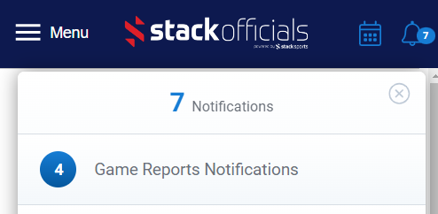
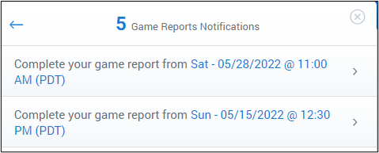
2. Click the icon along the right edge to OPEN the tile with game details. The “Complete Game Report” button will automatically link to the correct type of report.
Note: To include incident reports immediately following your game report - checkmark the option provided.
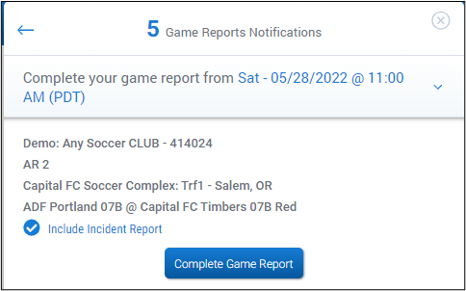
Report type for integrated games (with Sports Connect)
Enter the Home and Away scores, then click SAVE SCORE. If the scores were already entered, you can Continue to Add Cards and/or include a comment for the game.
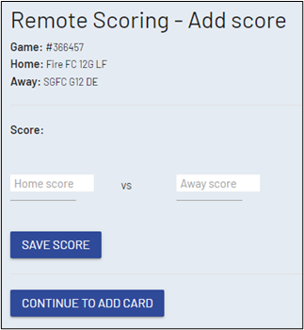

Report type for NON-integrated games
Click on the plus sign to create a report, then enter Home and Away Scores and the number of cautions and send-offs (if soccer). Depending on the event settings, you may have the option to include a Game Note and/or Attachments (such as a photo of a roster, field condition, etc).
Remember to click “Submit” when finished.

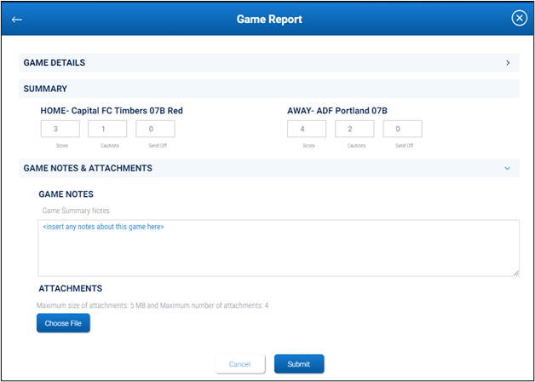

If you need to ACCESS or EDIT your reports
From your dashboard, select the DATE of the game, then open the desired Game Tile which has all the details. Links to post-game reports will appear once the game is over. Click or tap on the word “Game” in blue text.
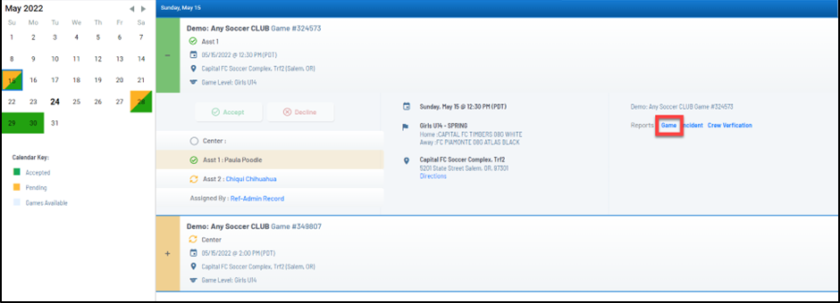
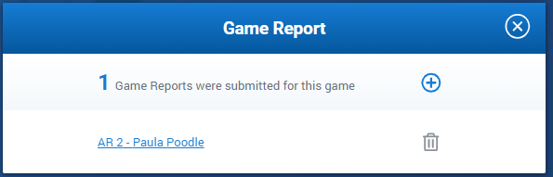
- To EDIT your report, click on the blue letters/link to report
- To DELETE your report, click on the garbage can icon
- To ADD another report, click on the + icon
- LOCKED report? A green check mark indicates a report in Approved status. Please contact the Event administrator or your Assignor if you need to edit an approved/locked report.

