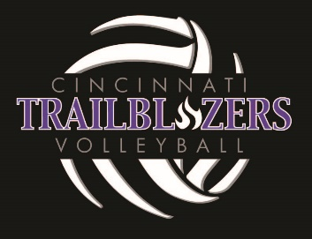

Assumption of Risk and Waiver of Liability
Cincinnati Trailblazer Booster Club (hereafter referred to as the “Trailblazers”) has put in place numerous preventative measures and enhanced cleaning protocols to reduce the likelihood of spreading COVID-19; however, Trailblazers cannot guarantee that you or your child(ren) will not become infected with COVID-19. Further, attending sponsored activities with Trailblazers could increase your risk and your child(ren)’s risk of contracting COVID-19.

By signing this agreement, I acknowledge the contagious nature of COVID-19 and voluntarily
agree to assume the risk that my child(ren) and I may be exposed to or infected by COVID-19 by
attending Trailblazer events and that such exposure or infection may result in personal injury, illness, permanent disability, and death.

I understand that the risk of becoming exposed to or infected by COVID-19 with the Trailblazers may result from the actions, omissions, or negligence of myself and others, including, but not limited to, Club Directors, Coaches, Athletes and their families. I voluntarily agree to assume all of the foregoing risks and accept sole responsibility for any injury to my child(ren) or myself (including,
but not limited to, personal injury, disability, and death), illness, damage, loss, claim, liability, or
expense, of any kind, that I or my child(ren) may experience or incur in connection with my
child(ren)’s attendance with Trailblazers or participation in Trailblazer programming.

On my family’s behalf, and on behalf of my children, I hereby release, covenant not to sue,
discharge, and hold harmless Trailblazer Booster Club, its employees, agents, board members, and representatives, of and from the Claims, including all liabilities, claims, actions, damages, costs or expenses of any kind arising out of or relating thereto.

I understand and agree that this release includes any Claims based on the actions, omissions, or
negligence of Trailblazers, its employees, agents, and representatives, whether a COVID-19 infection occurs before, during, or after participation in any Trailblazer activity.

Player Name: _________________________________________________________
Parent or Guardian Name: ______________________________________________
Parent or Guardian Signature: ___________________________________________
Date: _________________________________________________________________

