- Gear (Located in equipment shed)
  - Ball/Strike Counter
  - Small Broom
  - Chest Protector
  - Protective Cup (bring your own!)
  - Shin Guards
  - Face Mask

- Pre-Game
  - Check all bats, helmets and catchers gear to ensure they are legal (USA bats with no dents or cracks) and safe (no cracks in helmets, catcher’s mask has a neck guard etc.)
  - Meet with coaches 5 minutes prior to game time to get lineups and greet

- Game Timing
  - 2-hour time limit, no new inning after 1:45
  - 7 warm up pitches for a new pitcher, 5 for a returning pitcher. Any player warming up the pitcher must wear a face mask and may only crouch in to the catcher’s position if he is wearing a cup. Only players can warm up a pitcher.

- Positioning – Behind the Plate
  - Look between batter and catcher, bottom of chin even with catchers’ helmet, keep head still!
  - Keep ball/strike counter in left hand

- Strike Zone - Be Consistent, Confident and Loud!!!!
  - General guidelines are to keep the game moving. Be liberal with the strike zone, call outs on close defensive plays and keep the game moving!
  - Zone is generally between the armpit and knees, over the plate plus the width of 1-2 baseballs on the outside portion of the plate. Larger for minors’ level. See figure below.
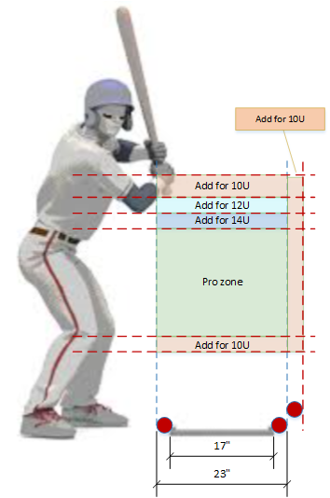
General Rules
- Don’t make a call it if you didn’t see it. Ask the other umpire for help or let it be.
- The ball is not dead on a foul tip (runners may advance at their own risk). 3rd strike foul tip is an out if catcher catches it direct to glove (which is sharp and direct to catcher’s glove).
- If a base runner leaves early (in general, they are not allowed to score on a batted ball and are sent back if the ball is not put in play - after the defense has a chance to make the out). Rule book (section 7.13).
- A ball is not foul until it is touched in foul territory or touches the backstop or when it goes past 1B or 3B.
- Batted ball hits the plate is not a foul ball, unless it comes to rest in foul territory.
- Hands are not part of the bat
- If you swing and are hit by pitch, it is a strike (and a dead ball)
- Technically umpire should not be coaching. You should relay your thoughts to the coach between innings.
- Although there is a two-hour game time rule, the required amount of innings (4, or 3 ½ if home team is winning) MUST be played to constitute a legal game. If an inning starts before the time limit, it will be completed (Home book will keep time).
- Players may advance on a passed ball or may steal when the pitched ball reaches the batter (this includes home plate).
- Minors: Coach may visit pitcher twice per inning (third visit requires a pitching change). Manager may visit each pitcher three times per game; fourth requires a pitching change.
- Majors: Coach may visit pitcher once per inning (second visit requires a pitching change). Manager may visit each pitcher three times per game; fourth requires a pitching change.

Majors Only

- Catcher must catch strike 3 to record an out with less than two outs and first base not occupied, or with two outs and first base occupied or not occupied. Rule reads: A batter is out when a third strike is not caught by the catcher when first base is occupied before two are out.

- Infield fly rule: An Infield Fly is a fair fly ball (not a line drive or bunt) that, in the judgment of the umpire, can be caught by an infielder, pitcher, or catcher with ordinary effort and when there are runners on first and second or first, second, and third and less than two outs. When the umpire calls "infield fly” the batter is out, regardless of whether the ball is subsequently caught or dropped. The ball is live, and runners already on base may advance (at their own risk) if the ball is not caught or tag up and advance if it is caught.

