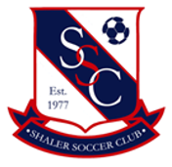
Shaler Soccer Club Spring 2022 Flower Basket Sale
**Hanging Basket size is 12 inches. Cost - $25.00/basket**
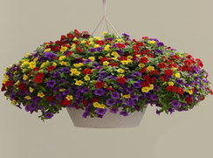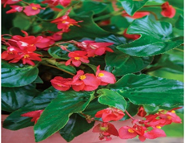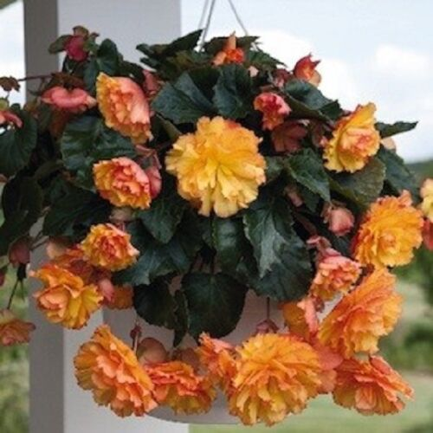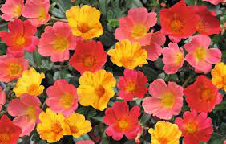
Million Bell Mix Dragonwing Begonia Illumination Begonia – Gold Portulaca Cupcake Mix
 | Million Bell | Portula Cupcake | Illumination Begonia | DragonWing Begonia |  | Upright Geranium |  | New Guinea Impatiens |  |  | Total
Name | # Mix | # Mix | # Gold | # Red | # Pink | # Red | # White | # Pink | # Sweet Cherry | # Orange | Baskets | Cost
Totals

In partnership with one of our sponsors, Fred Bartsch Greenhouse, Inc., Shaler Soccer Club is proud to again offer spring flower baskets for purchase as a fundraiser in support of our spring 2022 season.
Order Deadline: Saturday, April 23rd Order Pickup: Saturday, May 7th at Fawcett Field
There will be a collection basket available at Denny field during practices/games for order turn in.
** Additional information regarding pick-up will be sent prior to the delivery date. **

Order Forms and Payment can be given to your coach, Kim Rios or Kate Koch in an envelope marked Basket Sale.
Checks should be made out to “Shaler Soccer Club”.

Please email shalersoccerclub@gmail.com or Kim Rios (msukim@gmail.com) with questions regarding the sale.

-----------------------------------------------------------------------------------------------------------------------------------------------------------------------

Please turn in this portion with your payment to your coach or during practice/games at Denny Field by
Saturday, April 23rd 2022.
Player/Family name: _____________________ Player Age Group: ________ Phone number: __________________ Email:____________________________

Total | Million Bell | Portula Cupcake | Illumination Begonia | DragonWing Begonia |  | Upright Geranium |  | New Guinea Impatiens |  |  | Total
Baskets | # Mix | # Mix | # Gold | # Red | # Pink | # Red | # White | # Pink | # Sweet Cherry | # Orange | Paid

