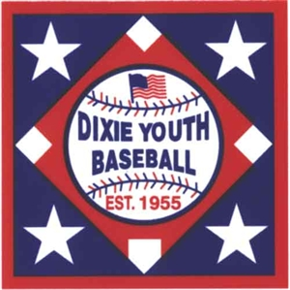

TO: Managers of Florida AAA/Ozone Coaches

FROM: 2022 Marianna State Tournament Committee

SUBJECT: Birthdays during Tournament

Player Birthdays

** Managers of teams or District Directors:

If you have a player who will be celebrating a birthday while here in Marianna during the tournament, please let us know. If we do not know we can not purchase a cake for them. Please fill out form and email back to Jeff Faircloth at jfaircloth@mariannafl.city Please send in by June 20, 2022.

Has a birthday on ______ (day) of ___________ (month).

Player Name: ___________________________________________________

Team:____________________________________________________________

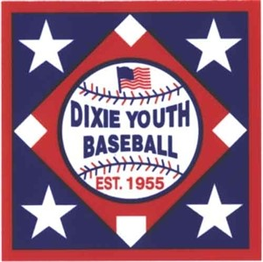

PRE ORDER BARBAQUE PLATES FOR $10.00
Night of event $12.00
TEAM NAME: ______________________________________________
NUMBER OF PLATES: _________ X $10.00 TOTAL $________________

PRE ORDER TOURNAMENT TSHIRTS FOR $20.00 at site $25.00
YS____ X $20.00 Total $______
YM____X $20.00 Total $______
YL_____X $20.00 Total $______
AS_____X $20.00 Total $______
AM____ X $20.00 Total $______
AL_____X $20.00 Total $______
AXL____X $20.00 Total $______
AXXL____X $20.00 Total $_____

PLEASE MAKE CHECKS PAYABLE TO MARIANNA RECREATION DEPARTMENT

