SLINGER SOCCER CLUB
PARENT AND ATHLETE AGREEMENT
Related to Concussion Law 2011 – Wisconsin Act 172

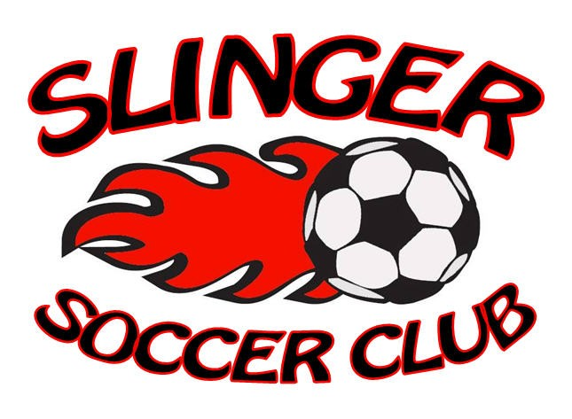

As a Parent and as an Athlete it is important to recognize the signs, symptoms, and behaviors of concussions. By signing this form you are stating that you understand the importance of recognizing and responding to the signs, symptoms, and behaviors of a concussion or head injury. This form must be completed before the first practice of every soccer season.

Parent Agreement:

I _________________________________ have read the Parent Concussion and Head Injury Information and understand what a concussion is and how it may be caused. I also understand the common signs, symptoms, and behaviors. I agree that my child must be removed from practice/play if a concussion is suspected.

I understand that it is my responsibility to seek medical treatment if a suspected concussion is reported to me.

I understand that my child cannot return to practice/play until providing written clearance from an appropriate health care provider to his/her coach.

I understand the possible consequences of my child returning to practice/play too soon.

Parent/Guardian
Signature_________________________________________Date__________________

Athlete Agreement:

I_______________________________ have read the Athlete Concussion and Head Injury Information and understand what a concussion is and how it may be caused.

I understand the importance of reporting a suspected concussion to my coaches and my parents/guardian.

I understand that I must be removed from practice/play if a concussion is suspected. I understand that I must provide written clearance from an appropriate health care provider to my coach before returning to practice/play.

I understand the possible consequence of returning to practice/play too soon and that my brain needs time to heal.

Athlete
Signature_________________________________________Date___________________

U Level________________________

