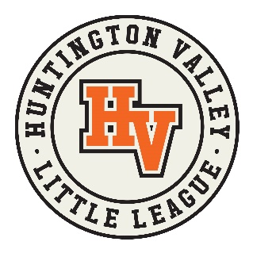
TROPHY/AWARD ROSTER

HVLL provides participation awards to all players in both Lower and Upper Tee-Ball Divisions, and Farm.
In Majors, Minor A, Minor B, and Minor C awards will be given to the top 2 (two) teams in each division.
- Please complete the form below by typing each player’s first and last name in the space provided.
- Have each parent carefully review the spelling of their player’s name.
- HVLL is not responsible for spelling errors provided on this form.
- Submit this form to Christina Peterson: christinamariepeterson@yahoo.com

Division: _______________________ Team: _________________________

Manager Name: ____________________________

Team Parent Name: _________________________

Team Parent Phone: ___________________ Team Parent Email: ________________________________________

PLAYER NAME (First & Last)

1.

2.

3.

4.

5.

6.

7.

8.

9.

10.

11.

Completed forms MUST be submitted on or before Opening Day, February 26, 2022.

