Ala Puumalu Field Procedures
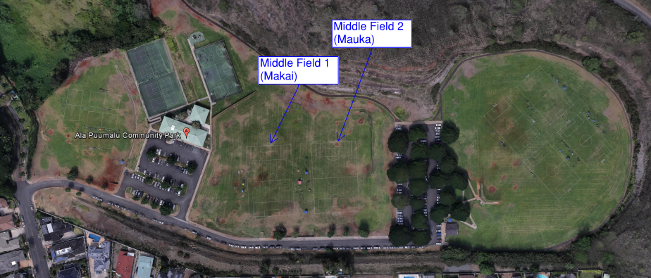
10U – Middle Field
- Field Set Up
  - Equipment for the field (paint and paint machines, corner flags, goals w/nets and equipment bucket) will be delivered 30 minutes prior to game time. Equipment buckets to contain 1 hammer, 10 pegs, referee flags and cones.
  - Home team lines the field before the first game. Visiting team to set corner flags.
  - Both teams to set up one goal each.

- Team Set Up
  - Visiting team to set up on the makai side of the field, home on the mauka.
  - Coaches and players to remain it the coaches box and parents and other spectators to remain outside the box.

- Referees & Team Responsibilities
  - Home team to provide water to the referees during half time.
  - Referees to provide completed game cards to the referee tent in between the two fields. If referees need assistance, check with referee tent.
  - Before the game, check field for condition and goals to make sure they are safe. Cones in the equipment bucket can be used to mark unsafe field locations.

- Field Breakdown
  - After last game, teams to breakdown and put away one goal each. Leave the net on one of the cross bar pieces.
  - Collect all 10 pegs and return to the bucket.
  - Collect 4 corner flags and poles
  - Bring equipment to the side of the street for easy pick up.

