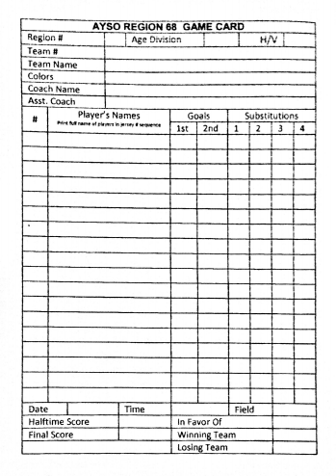

**68**

**GU12**

**251**

**TM name**

**Color**

**Coach**

**Asst**

**2**

**3**

**4**

**5**

**6**

**7**

**8**

**9**

**10**

**11**

**12**

**13**

**14**

**Player**

**Player**

**Player**

**Player**

**Player**

**Player**

**Player**

**Player**

**Player**

**Player**

**Player**

**Player**

**Player**