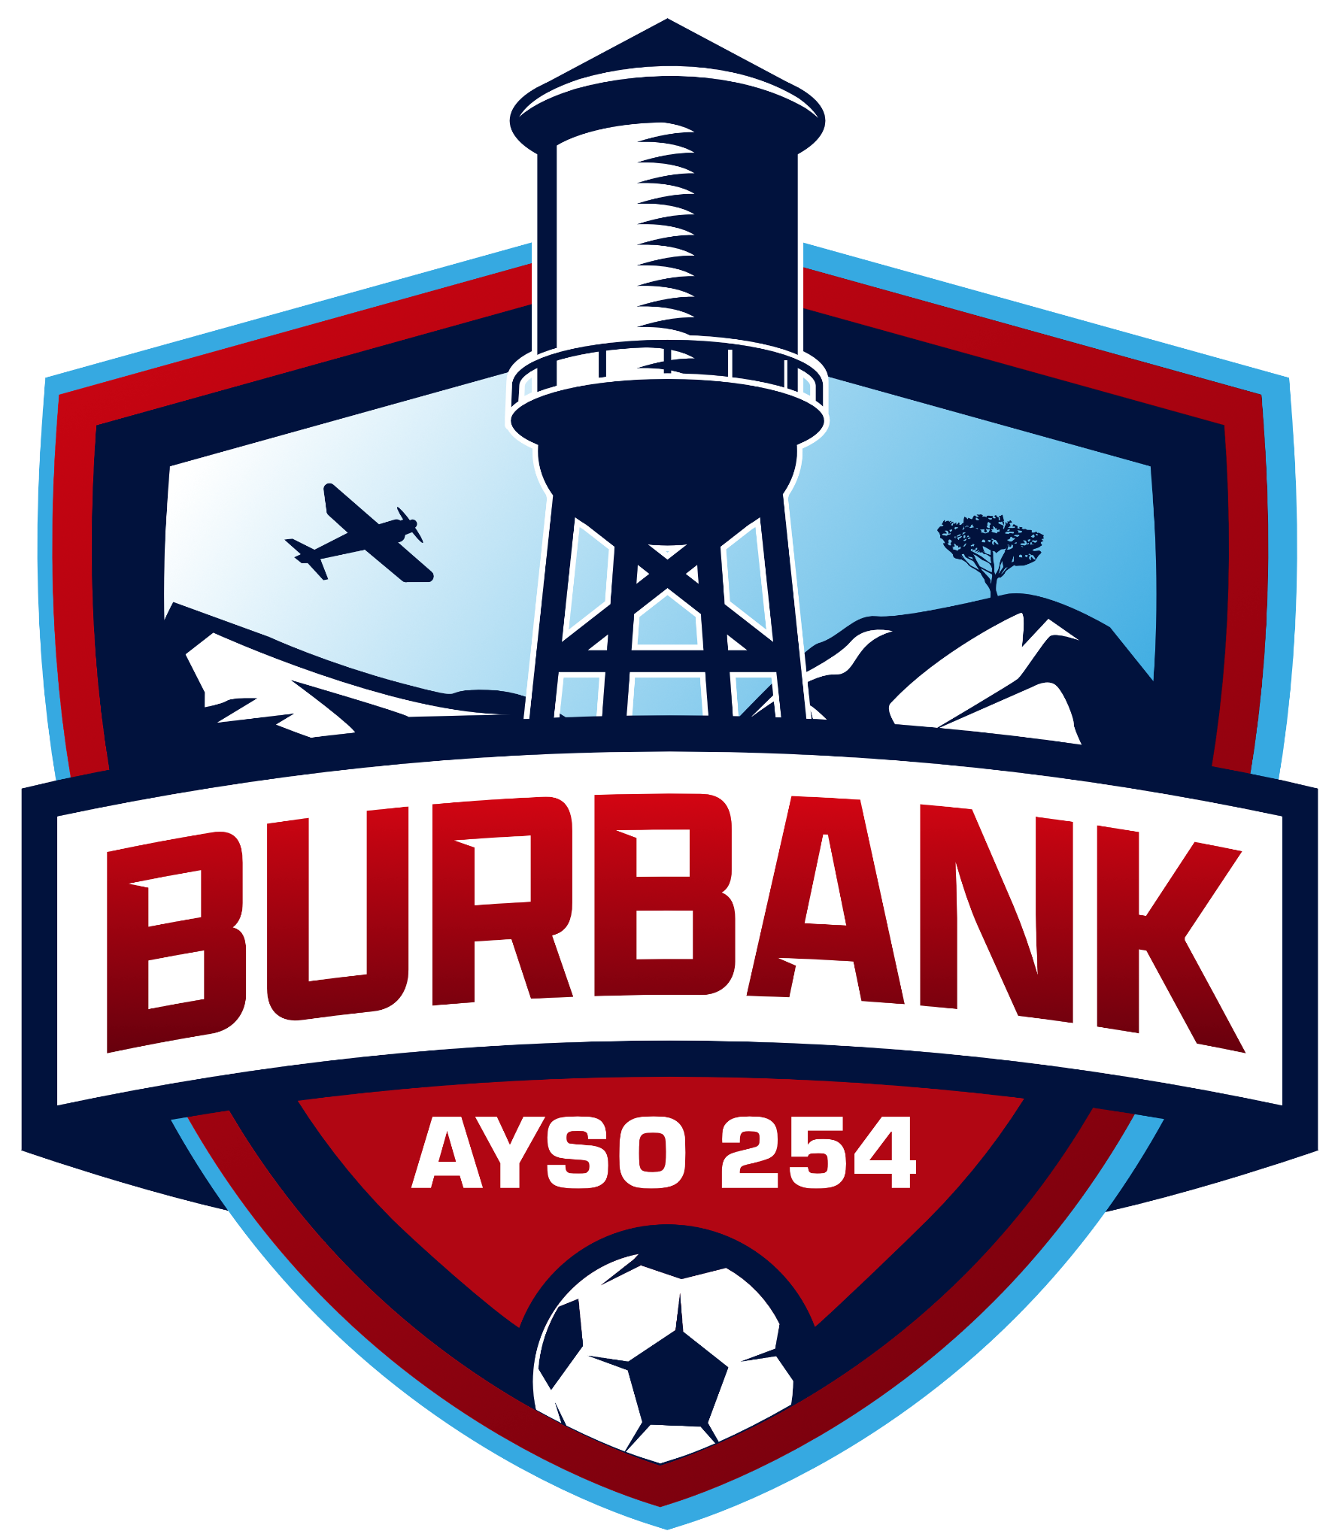
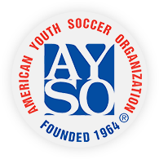
Region 254 Meeting Minutes
Zoom
April 6, 2026 · 8:00pm

 | TOPIC |  | PRESENTER
Meeting called to order at 8:06 pm  Welcome, Attendance: Sarah Brown, Brett Meade, Leanne Solish, Tim Lovestedt, Mark Yamarone, Scott Elkin, Jonathan Ontiveros, Katie Ybarra, Lauren Koenig, Lea Ford, Ira Sherak, Suzy Flores, Myles Collins, Greg Samarge, Has Badalian Collins, Brian Williams, Neela Woodard |  | Sarah Brown  Regional Commissioner
New Business  Important Dates:  Board Appreciation Brunch: April 19, 2026, Smokehouse  - Please RSVP if you haven’t  EXPO Wrap Up:  - Last week or two  - Good Board representation  - Lots of great things happening  Field Updates:  - Not too much to report,  - Some new hires that will take over on July 1 at BUSD  - Goal is to get Joint Use Agreement in place with BUSD  - Permit request goes from BUSD facilities to the principals  - BUSD facilities is moving forward with a new scheduling system that may be more automated, also moving forward with a fee study that may affect us  - Encourage good relations with BUSD at sites  - Sooner we open registration the better, hopefully encourages operating at the status quo with BUSD for upcoming fall season  Spring Season:  - Has been going well from informal reports  - Kids received a playing card, Bee Up will pass out snacks next week  - One color t-shirt and pinnies are working well  Fall Season:  - Registration Calendar:  - Open Registration: April 20, 2026 (possibly sooner if it can be set up earlier)  - Early Bird Ends: May 25, 2026 (Memorial Day)  - BUSD ends May 28  - Waitlist Begins: July 1, 2026  - Season Calendar:  - End of July: coach training, player evals, livescan  - Draft: First week of August  - Opening Day: August 29  - Two weeks without play due to Labor Day and Rosh Hashanah  - If we play 10 weeks, there is no wiggle room.  - Only trouble spot may be 14U based on post-Region playoffs.  - Add an in-person orientation the Saturday before games begin, or possibly Saturday after school starts, will hopefully encourage volunteers, explain post season, carrot at the end is getting uniforms.  - Pricing:  - Last year $235, $195 for early registration  - Greg Samarge, Treasurer: Have effectively broken even over the last three years, but some costs come in late  - Recommend small increase in price, $10 increase  - Have slightly trended down in registrations  - Small multi-family discount (same as last year): $25 per each family member  - Motion: Set pricing for fall season  - $205 early bird registration, $240 regular registration, $25 per additional child in a family, $25 for EPIC registration  - Motion made by Greg Samarge, Has Badalian Collins second, Motion Carries  - Age Change: year-age is August 1-July 31  - Intention for rule change is so kids can play with their grade  - Should kids born in August play with their grade?  - Do we go with what Area does?  - Discussion had, decide to stay with US Soccer guidelines due to unforeseen issues  Community Events:  - Tim Lovestedt: Show up at local events and have a booth  - Sarah: shared some marketing mock-ups  - April 25: can anyone come to help register at Spring Soccer?  National Games:  - Bids Open on July 1, 2026  - In Huntsville, AL  - Are we ok with putting in a bid? What divisions do we prefer?  - Probably prioritize largest registration numbers  Board Positions to fill:  - Secretary  - Purchaser  - Division coordinator:  - Split 7U/8U  - 14U  - 10UB  - Volunteer Coordinator/Team Manager Coordinator  - Community Liaison |  | Sarah Brown  Regional Commissioner
Adjourned at 9:55 pm |  | Sarah Brown

