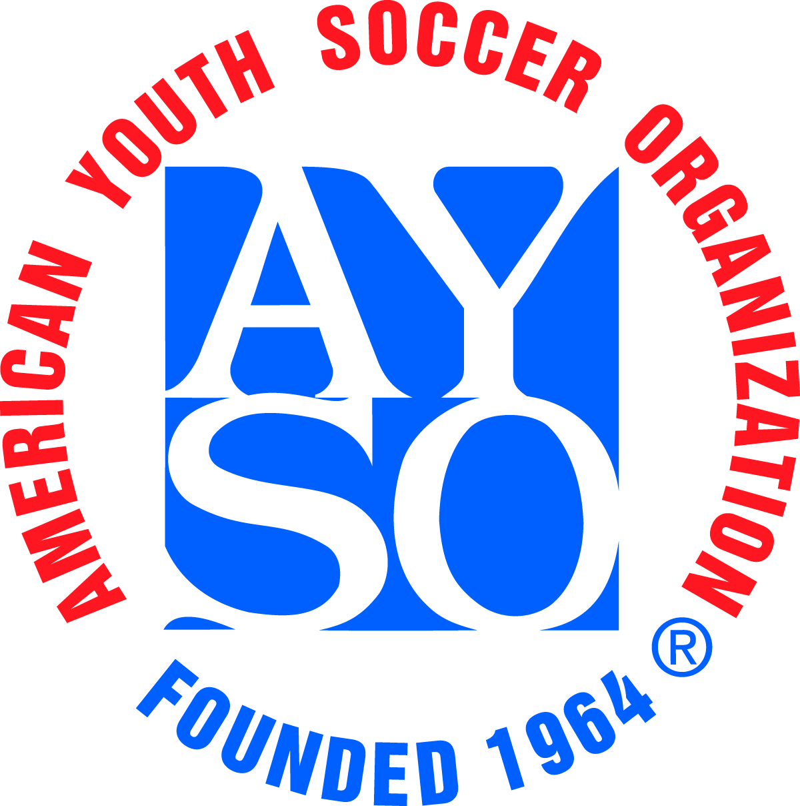 |  | Chino Milkcan Tournament  Referee Information Form |  |  |  |  |  |  |  |  |  |  |  |  |  |  |  |  |  |  |  |  |  | 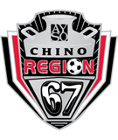
I plan to bring a referee team to the tournament Y/N: |  |  |  |  |  |  |  |  |  |  |  |  |  |  |  | Referee Information Form Date:
Region: |  |  |  |  |  | Team Name:

Coach Name:
Age Division: |  |  |  | U-10 |  |  |  | U-12 |  |  | U-14 |  |  | U-16 |  |  |  | U-19 |  | Boys |  |  | Girls |  |  | Coed

Referee Team Contact Person
Name: |  | Email Address:
Day Phone: |  | Evening Phone:
Provide the following information for each referee.
- “Badge Level”, insert R = Regional, I = Intermediate, A = Advanced, N = National. Also, the date they were certified at that level.
- In each box under “Center/Assistant/Boys/Girls”, provide the highest level they are competent to referee (e.g., BU-10, GU-12, etc.)
- In “Player on Team”, indicate if the referee has a child who is playing in the tournament on this team.

 | Referee Name | Badge Level | Certifica-  tion Date | Center |  | Assistant |  | Player on Team (Y/N) | Home Phone/ Email
 |  |  |  | Boys | Girls | Boys | Girls | Player on Team (Y/N) | Home Phone/ Email
1
2
3
4

Each referee will receive a tournament T-Shirt. Please indicate sizes needed. All sizes are Adult.
 | XXL | XL |  | L |  | M | S
Number of Shirts Needed
Regional Referee Administrator’s Name |  |  |  |  | Phone Number |  |  |  |  | Email
By my signature below, I certify that all referees listed are Certified per AYSO National Guidelines and qualified for officiating U-10 through U-14 games as indicated above.
RRA Signature and date (Blue ink please)

Area Referee Administrator’s Name |  | Phone Number |  | Email
By my signature below, I certify that all referees listed are Certified per AYSO National Guidelines and qualified for officiating U-16 and U-19 games as indicated above.
ARA Signature and date (Blue ink please)

