**Log into your account**

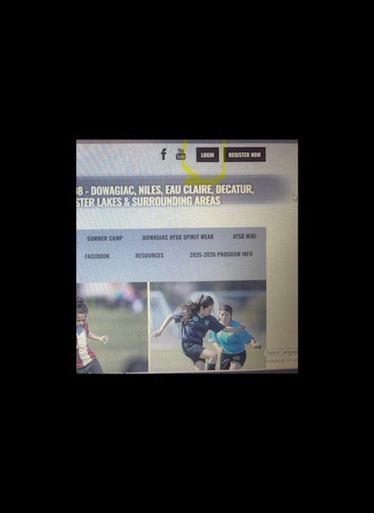

**Click My Account**

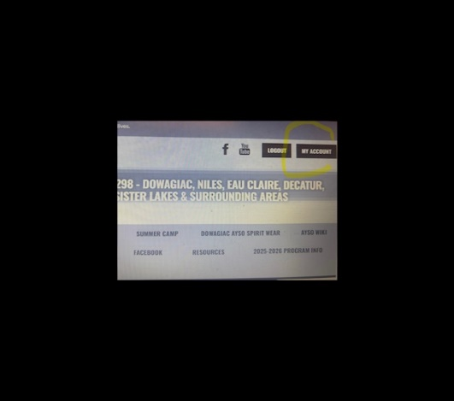

**Click AYSOU**

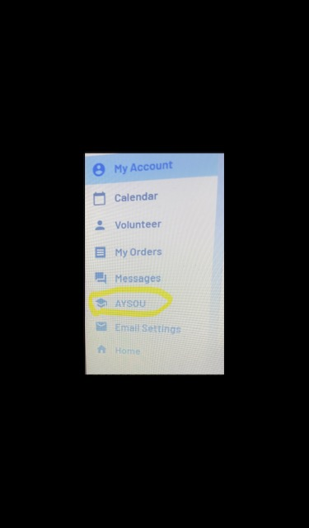

**Click Training Library**

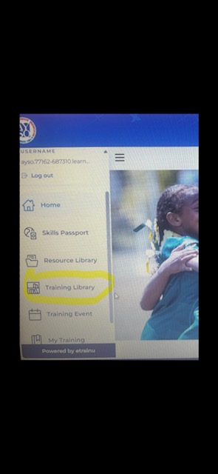

**Click View Courses under the coaches category**

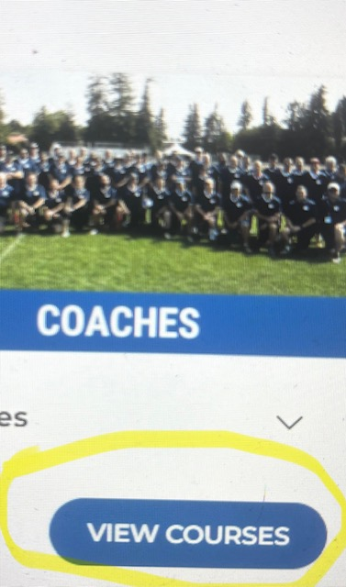

**Click Enroll Under 6U**

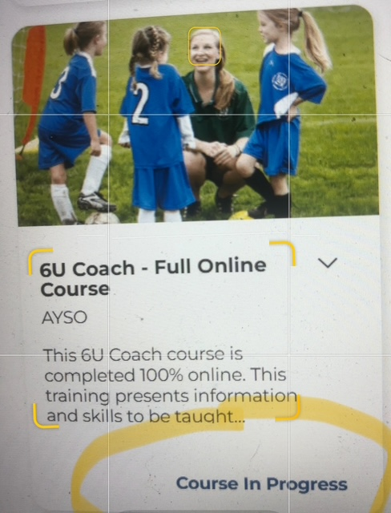

**Take all the courses in this section. Save Certificates, if you don’t finish and return at a later time. Click**

**My Training there, you will find the category to finish**

