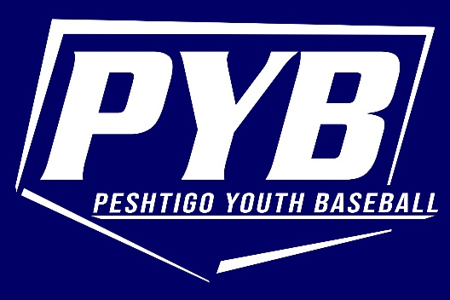

Dear Friend of Peshtigo Youth Baseball:

We are fast approaching our 2023 season and would like to invite you to sponsor Peshtigo Youth Baseball. We are a non-profit organization that aids in the development of youth baseball for boys and girls ages 5-15. With fundraising and generous support from companies and individuals like you, we can keep PYB running smoothly.
Grand Slam Sponsor ($300), you can sponsor a team in PYB. This sponsorship will advertise your business in all team communications, schedules, and roster. Also, your company name and logo will be printed on a 3’ x 5’ color vinyl banner. These banners will be displayed on the fences at the baseball fields throughout the season and are seen by parents, coaches, and spectators from Peshtigo and surrounding cities.
Home Run Sponsor ($150), you can advertise with us on a 3’ x 5’ color vinyl banner. These banners will be displayed on the fences at the baseball fields throughout the season and are seen by parents, coaches, and spectators from Peshtigo and surrounding cities.
All sponsorships will also be included on the PYB website, as well, as displayed outside each concession stand.
We also gladly accept any donations you would like to give. These donations help provide equipment for the kids such as catching gear, pitching machines, bats, helmets, and baseballs. It also enables PYB to give scholarships to those children that otherwise would not be able to play.
Thank you on behalf of PYB for your continued and generous support.
Enclosed is a sponsorship form. Please return the completed form to the address listed. We appreciate your time and willingness to support Peshtigo Youth Baseball!

Sincerely,
Jason Lemire
President
Peshtigo Youth Baseball, Inc.

PESHTIGO YOUTH BASEBALL 2023 SPONSORSHIP

- Grand Slam Sponsor ($300)
OR
- Home Run Sponsor ($150)
(Please provide your company logo if first year sponsor)

Please provide the following information:

Name: _______________________________________________________________

Company: ____________________________________________________________

Address: ______________________________________________________________

If first time sponsor, please email company logo to peshtigoyouthbaseball@gmail.com
Please make checks payable to Peshtigo Youth Baseball and mail along with this sponsorship form to:
Peshtigo Youth Baseball
PO Box 41
Peshtigo, WI 54157

