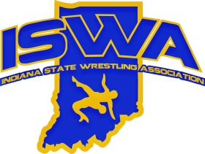

2026 Heartland Duals Team IN (MS)

The MS National Duals trip to Council Bluffs Iowa for the Heartland Duals were very successful for Team IN.
Both MS teams have finished in the top 11 of the country.

Team IN Gold placed 3rd in the Diamond bracket pool (3rd out of 29 teams)
Team IN Blue placed 3rd in the Platinum bracket pool (11th out of 29 teams)

Coaches:
Gold team: Sam Riesen, Matt Kelly
Blue Team: Alex Ponce, Tad Dranger

Roster:
Gold Blue

75 Trey Sanderson 6-2 Mason Horner 5-2
80 Henry Riesen 5-3 Cole Szypczak 4-3
85 Lynkoln Hammond 4-4 Jeremiah Maldonado 8-0 AA/MVP
90 Deangelo Chavez 8-0 AA/MVP Gage Peterson 3-4
95 Carter Marsh 4-4 Jonah Martinez 6-1
102 Haedyn Cochran 7-1 Harry Scott 3-4
110 Max Kessinger 5-3 Grayson Babjak 3-4
117 Camden Hook 8-0 AA/MVP Alexander Ponce 6-1
125 Maverick Hoehn 7-1 Carson Planer 6-1
132 Braxtyn Bauer 7-1 Maximus Cantu 5-2
140 Will Carney 7-1 William Scruggs 3-4
150 JJ Doty 7-1 Josiah Schultz 5-2
160 Will Smith 4-4 Christian Labushagne 6-1
175 Caleb Devault 3-5 Peter Dranger 2-5
195 Noah Fitzgerald 7-1 Pedro Tirado 1-6
220 Mason Heidelberger 7-1 Paxton Felix 5-2
275 Olywapelumi Akinremi 6-2 Deuce Woods 5-2

**AA= All American undefeated wrestler
**MVP= designated as Team Outstanding Wrestler

Pictures:

MS Gold
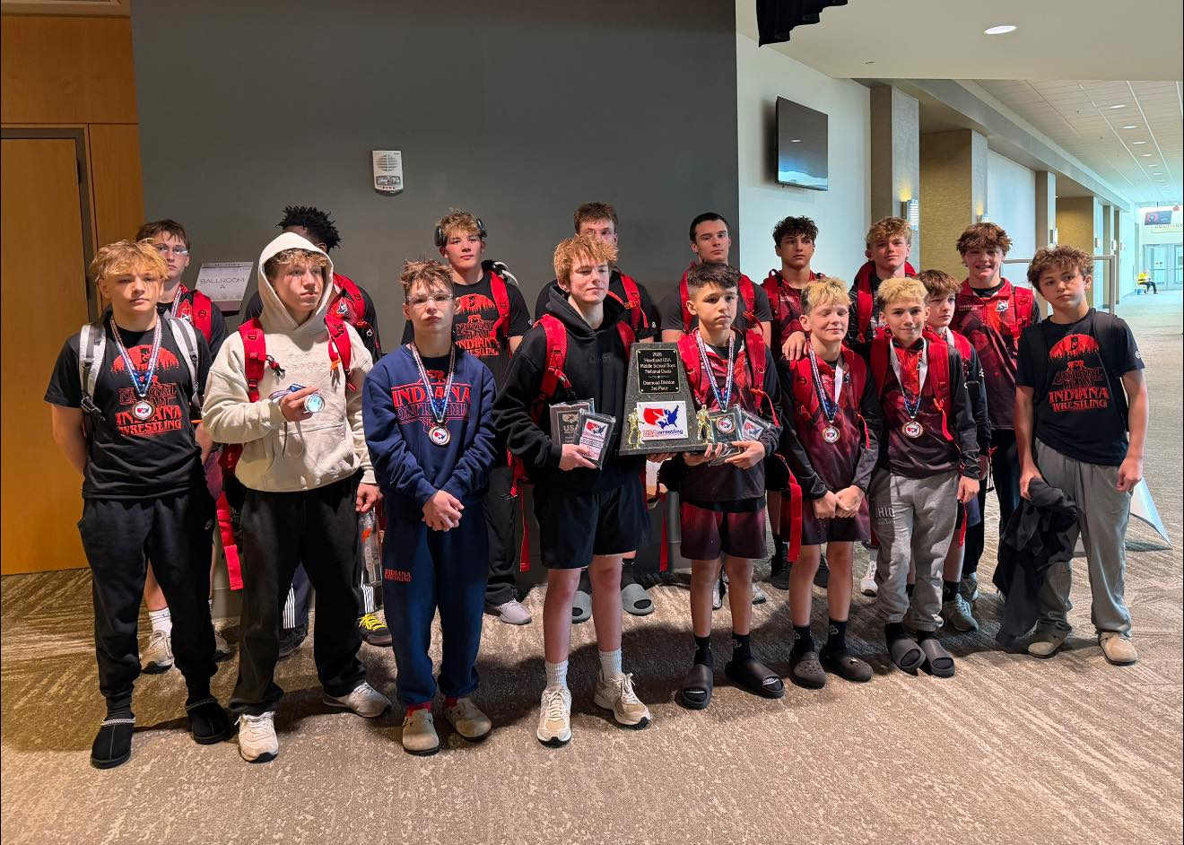

MS Blue
