Greg Muhr - Bio

Greg Muhr-Select Coach-2005 Girls

Greg is from Hoffman Estates, Illinois, he attended Eastern Illinois University and graduated with a Bachelors Degree in Psychology.

While attending Eastern Illinois University he played four years at the college. After college he played with the Chicago Power, Chicago Stingers, Detroit Rockers and the St. Louis Storm. He was the 3rd pick overall for the St. Louis Storm. During his time with Chicago Power Greg began coaching for Barrington High School and Barrington Area Soccer Association.

After his pro career Greg moved into coaching fulltime. Greg coached for the Chicago Cobras, a women's pro team, for five years earning coach of the year one of those years. Greg also coached one summer for the Colorado Fort Collins Force woman's pro team. Greg owned as well as coached for Exodus Soccer Club. He has also spent time coaching for Sockers, NSA, Chicago Fire Juniors and was ODP Region 2 Assistant Head Coach for 3 years. Greg has also coached two U14 national ID Camps.

Greg holds a USSF B license.
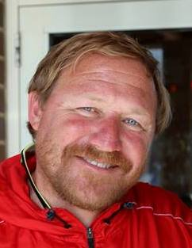

Greg Muhr
Select Coach
P.O. Box 481
St. Charles, IL 60174
773-331-1678
greg@chicagorushsoccer.com

