2015 Hobe Sound Soccer Club Sponsorship Application

Hobe Sound Soccer Club
8771 SE Bridge Road #215
Hobe Sound, FL 33455
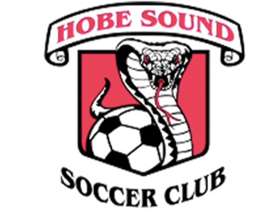

Thank you for supporting the Hobe Sound Soccer Club! As a team sponsor you will enjoy the following
- Company/Organization name on sponsor board
- Team plaque
- Recreational sponsors will have their Company/Organization name on game jersey
- Partners ($500 and over) will have Company/Organization name on practice jersey

Company Name/Organization: __________________________________________________________________________________

Address: _____________________________________________________________________________________________________________

Contact Information: _______________________________________________________________________________________________

Phone Number: ____________________________________ Fax: _________________________________________________________

Email: ________________________________________________________________________________________________________________

Name to Appear on Equipment, Jersey, Etc.:

Are you sponsoring your own child’s team? Yes No

If yes, Child’s Name: ___________________________________________ Boy or Girl (circle one)

Age Group: __________________________________________________________________________________________________________

If your child’s team already has a sponsor would you sponsor a team in need?_________________________

Sponsorship levels (circle one):

$1500 Soccer Bag Partner $1000 Water Bottle Partner $500 All Star Partner

$300 U10 and above Recreational Team Sponsor $200 U8 & U6 Team Sponsor

Amount enclosed: _____________________

Please make checks payable to HOBE SOUND SOCCER CLUB

Signature: _______________________________________ Date: ___________________________________________________________

