As we move closer to the start of the Fall 2020 season, we want to let you know what protocols will continue as practices start and tournament play is considered. Our coaches are going through an in-depth Coach Development Session prior to that start of practices, in order to review the protocols, put in place by the Rush Union Health and Safety Task Force. We want to ensure a safe return to the soccer field for all or our players and coaches.

Parents and guardians also have a part in this safe return. Please monitor you player for any symptoms of COVID 19. If they have a fever or display any other symptoms of the Coronavirus, please keep them home. Please notify us immediately if your player develops COVID 19.

Team Practices:
Each team should plan to host a Zoom Team Meeting to discuss team goals and plans for the season, as well as to go over all the Health and Safety Protocols. The attached Protocols and Responsibilities items will continue as we begin practices. In addition:
- Practices will have staggered start times, to minimize the traffic flow on and off the fields.
- Do NOT drop your player off early for their practice and be sure to pick up on time.
- Temperature checks will continue at the start of practice, by a Rush Union Staff member.
- If you will remain at the field during practice, be sure to social distance and wear a mask.
- Teams will not scrimmage, outside of their own team, for the immediate future.

Tournaments
We have been reviewing the current guidelines that other organizations are implementing for their respective events to ensure our players are safe to participate in tournaments this August. Below are the published protocols from all tournaments our teams may be scheduled to play in during August. We are sharing them with parents and coaches, so you have a chance to review the information.

SSA Tournament August 15/16
https://soccer.sincsports.com/TTMore.aspx?tid=SSASC&tab=4&sub=10&Qual=MISC&Seq=18
NTH Tournament August 22/23 & 29/30
https://soccer.sincsports.com/TTMore.aspx?tid=NASACLB&tab=5&sub=0&Qual=MISC&Seq=8
AFC Lightning Tournament August 22/23
https://soccer.sincsports.com/TTMore.aspx?tid=AFCTLC&tab=5&sub=0&Qual=MISC&Seq=3
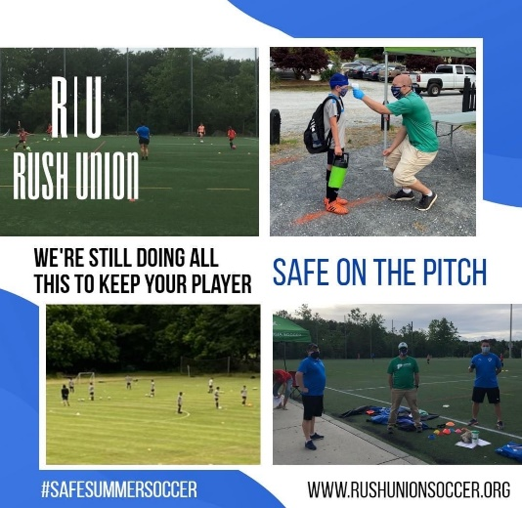

Rush Union Tournament Participation Policy during COVID
- If a player does not feel comfortable to attend an event and makes that position known prior to the team registering for the event, that player will not be responsible for their portion of the event cost.
- If a player withdraws from the tournament after the team has registered for the event, they will be responsible for their portion of the fee.
- Each tournament has their own refund policy and it is each team’s responsibility to know what that policy is.

If you have any questions about the return to play protocols, please reach out to us.

