Canon Mac Youth Football Association
P.O. Box 348
Canonsburg, PA 15317

Canon Mac Youth Football and Cheer is a community non-profit, all volunteer organization that appreciates the support of local businesses and all the community has done to keep our organization successful. Your support helps CMYFA buy equipment, rent facilities, purchase uniforms, pay for referees and EMT’s and even possibly allow a child to participate who does not have the financial means to register. Our organization will exceed 350 participants in our football and cheer programs this year.

We welcome all levels of sponsorships, donations and in-kind goods or services offered. We will recognize donations as described on the next page. CMYFA will also reimburse a registration fee for any family which raises $300 in collective sponsorships.

============================================================================
A “print ready” or “high resolution” electronic file must be submitted no later than August 1st, of current season to ensure availability for opening weekend. Banner ads may be full color images. APPROVAL: All files and requests submitted for banner will be subject to board review and approval. If a request is rejected, alternates may be submitted or donations will be returned.
============================================================================

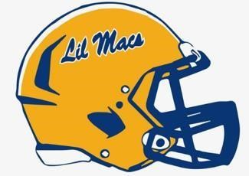
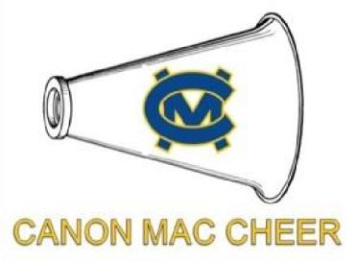
Canon Mac Lil Macs Sponsorship Application

I/We understand that sponsorship and donations to Canon Mac Youth Football Association are tax deductible as recognized by the 501(c)(3) IRS regulations. Note: a receipt will be mailed to you after your donation is processed.
CMYFA Tax ID # 81-1988470

CHECKS MADE PAYABLE TO: CMYFA

COMPANY NAME: _______________________________________________________________________________ ADDRESS: ______________________________________________________________________________________ PHONE: _____________________________ EMAIL: _________________________________________________ CONTACT: ____________________________________________ SPONSOR AMOUNT: ______________

=================================================================================== PLAYER NAME: ____________________________________________________________________________________ PARENT(S) or GUARDIAN: ________________________________________________________________________
PHONE: _____________________________ EMAIL: _________________________________________________ =================================================================================== We are looking forward to another successful season and the continued growth of the organization and our community. If you have any questions regarding our league or your form of contribution, please do not hesitate to contact me. We can also send you a PayPal link for your sponsorship contribution if that works better for your business.
Thank you!

Rodney Davis, CMYFA President Cell – 724-554-3256 Email – cmyfa1@gmail.com Web Site - www.lilmacsfootball.com

Canon Mac Youth Football & Cheer Sponsorship Levels

FIRST DOWN - $50
- Website Recognition as a FIRST DOWN Sponsor

- Your Company name will be added to the players sponsor t-shirts

- Your Company Name/Logo will be displayed on our website

REDZONE - $150
- Website Recognition as a REDZONE Sponsor

- Your Company name will be added to the players sponsor t-shirts

- Your Company Name/Logo will be displayed at the concession stand

- Your Company will receive a highlighted post across our social media sites

FIELD GOAL - $300 (Registration fee refunded to sponsored player)
- Website recognition as a FIELD GOAL Sponsor

- Your Company name will be added to the players sponsor t-shirts

- Your Company Name/Logo will be displayed at the concession stand

- Your Company will receive a highlighted post across our social media sites

- Multiple Game Day announcements to promote your business

TOUCHDOWN - $500
- Website recognition as a TOUCHDOWN Sponsor

- Your Company name will be added to the players sponsor t-shirts

- Your Company Name/Logo will be displayed at the concession stand

- Your Company will receive a highlighted post across our social media sites

- Multiple Game Day announcements to promote your business

- Receive a team photo to hang up at your place of business

CHAMPIONSHIP - $1000
- Website recognition as a CHAMPIONSHIP Sponsor

- Your Company name will be added to the players sponsor t-shirts

- Your Company Name/Logo will be displayed at the concession stand

- Your Company will receive a highlighted post across our social media sites

- Multiple Game Day announcements to promote your business

- Receive a game ball signed by the players or a Jersey with company name

