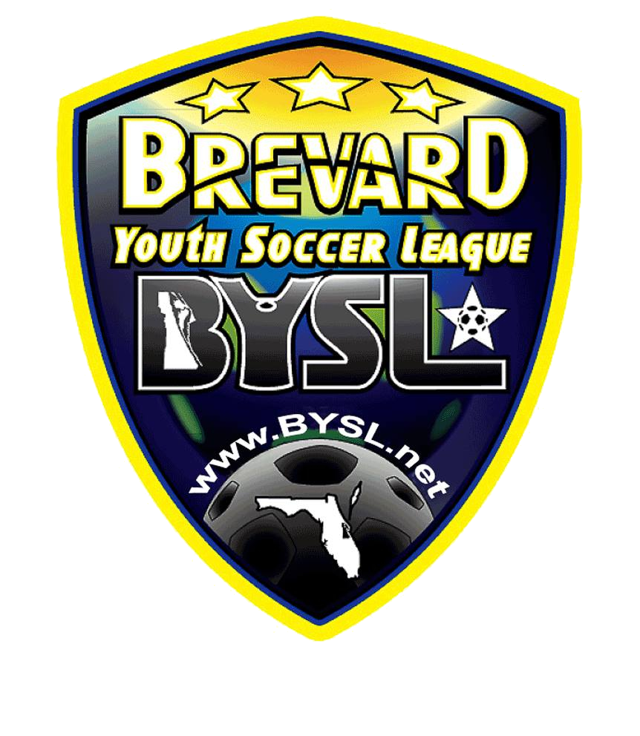
Point of Contact Information - Fall 2021
Brevard Youth Soccer League

MEMBER CLUBS

Club Name | Club | Contact | E-mail | Phone
Brevard Beachside Impact | BBSC | Lisa Soderberg | registrar@BeachsideImpact.com | 321-508-7102
Brevard Beachside Impact | BBSC | Chad Pinnick | chad@beachsideimpact.com | 321-795-9280
Brevard Beachside Impact | BBSC | Ryan Beal | ryan@beachsideimpact.com | 321-271-4821
Brevard Soccer Academy | BSA | Kevin Henderson | Kevin.henderson@brevardsoccer.org | 321-960-1311
Central Brevard | CBS | Holly Gibney | centralbrevardsoccer@gmail.com | 321-684-9187
Indialantic Soccer | IYSA | Georges Aboutanos | gaboutanos@gmail.com | 321-693-5021
Indian River Soccer | IRSA | Ian Brice | doc@irsoccer.com | 772-559-5365
Port St. John | PSJ | Ian Sterling | psjunited.scheduler@gmail.com | 321-432-4288
Sebastian Soccer Assoc. | SSA | Scott O'Brien | obrien30@bellsouth.net | 772-538-6453
Space Coast United | SCU | Matt Shannon | scheduling@spacecoastsoccer.org | 321-960-7984
Space Coast United | SCU | Hugh Cousins | rec@spacecoastsoccer.org | 321-514-5608
Titusville Soccer Club | TSC | Joe Barretta | tscvp@yahoo.com | 321-480-8001

1 Updated September 2021

