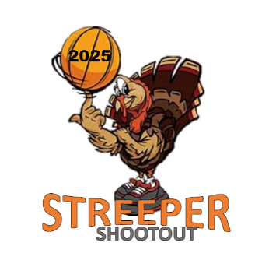

13TH ANNUAL JOHN STREEPER MEMORIAL BASKETBALL SHOOTOUT RULES

GAME RULES (ALL DIVISIONS)
- Rules will follow ICBA (http://www.icbabasketball.com/ ) unless indicated differently below.
- 5 personal foul maximum, technical fouls count as a personal foul
- 2 full time-outs per half; 1 additional time-out per overtime; no carryover
- 20 Minute Running Clock (per half)
- Clock stops in last minute of each half
- 3 minute half time
- Shoot 2 free throws on 10th foul each half, 2nd Half team fouls carry into OT (NO 1+1 free throw)
- Players or coaches ejected (double technical) will be ineligible for balance of tournament
- No full court press in 1st half
- 2 Minute Overtime (clock will stop); No Double OT

PRESSING
- 3rd & 4th Grade – NO PRESSING
- 5th – 8th Grade: No Pressing 1st Half, Press Allowed in 2nd Half unless up more than 15 points

ZONE DEFENSE
- BOYS 3rd & 4th Grade: No Zone unless underneath out of bounds
- BOYS 5th – 8th Grade: No Restrictions

- GIRLS 3rd – 5th Grade: No Zone unless underneath out of bounds
- GIRLS 6th – 8th Grade: No Restrictions

