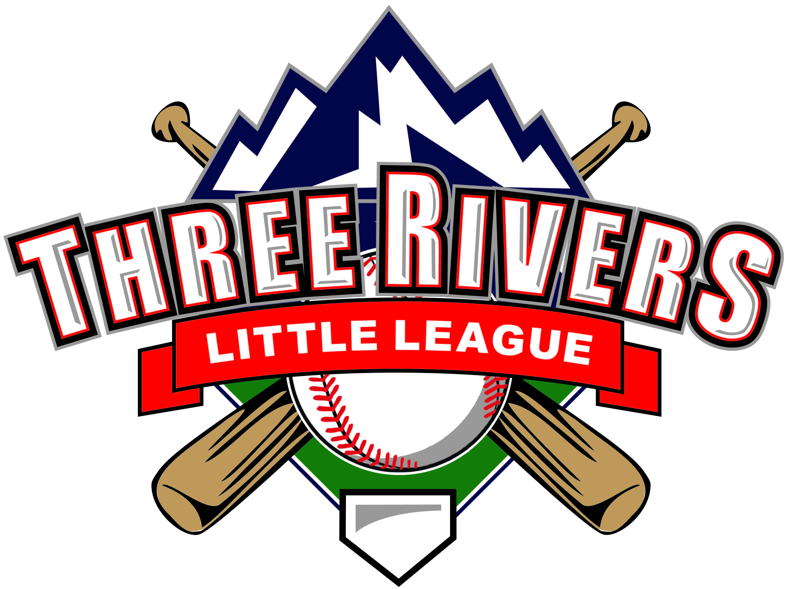

Sponsorship & Donor Packet

Welcome Letter
Dear Community Partner,
For over 40 years, Three Rivers Little League (TRLL) has provided youth in the Roaring Fork and Eagle Valleys with the opportunity to learn teamwork, sportsmanship, and the love of baseball and softball. Each year, more than 400 local kids step up to the plate thanks to the support of families, volunteers, and community sponsors like you.
With rising facility costs and the need to keep registration fees affordable, your sponsorship ensures that every child can play, regardless of financial ability. We invite you to join us in making a difference on and off the field.
With gratitude,
Three Rivers Little League Board of Directors
PO Box 2184
Glenwood Springs, CO 81602
Email: info@3riverslittleleague.com
Website: www.3riverslittleleague.com

About Us
Our Mission: Three Rivers Little League is dedicated to providing local youth with quality baseball and softball experiences through regular season games, All-Star opportunities, and minimal travel. We emphasize sportsmanship, teamwork, and personal growth, while engaging volunteers and leaders to foster a positive, learning-focused culture. Our goal is for every player to improve their skills, gain knowledge of the game, and grow as individuals, supported by a strong community of families and volunteers.
Who We Serve: Boys and girls ages 8-14 across the Roaring Fork and Eagle Valleys.
Impact:
- Over 400 players each year
- Dozens of volunteer coaches
- District championship teams
- Lifelong lessons in discipline, friendship, and leadership

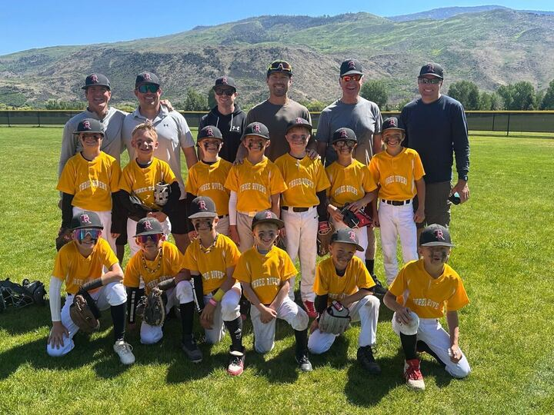

Why Your Support Matters
- Field rental fees and maintenance continue to rise exponentially.
- Equipment, uniforms, and safety gear are essential for every child.
- Keeping registration fees low ensures all families can participate.
- Community support allows TRLL to provide all players with 12 to 20 games per team and send All-Star teams to tournaments.
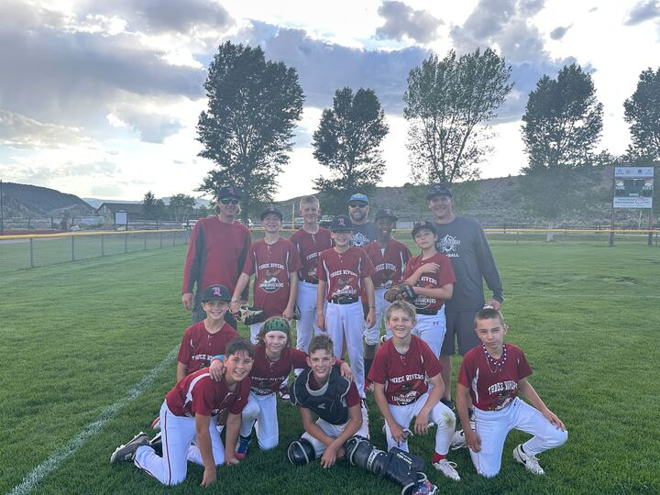

Sponsorship Opportunities
Level | Contribution | Benefits
Grand Slam Sponsor | $5,000+ | Linked large logo on main page of website  Recognition Opening Day Dedicated social media post
Home Run Sponsor | $2,500 | Large logo on website  Recognition at Opening Day Social media mentions
Triple Sponsor | $1,000 | Logo on website  Recognition at Opening Day Social media mention
Double Sponsor | $500 | Business name on website  Social media mention
Single Sponsor | $250 | Business name on website

In-Kind Donations – Contribute goods, services, or meals for events.

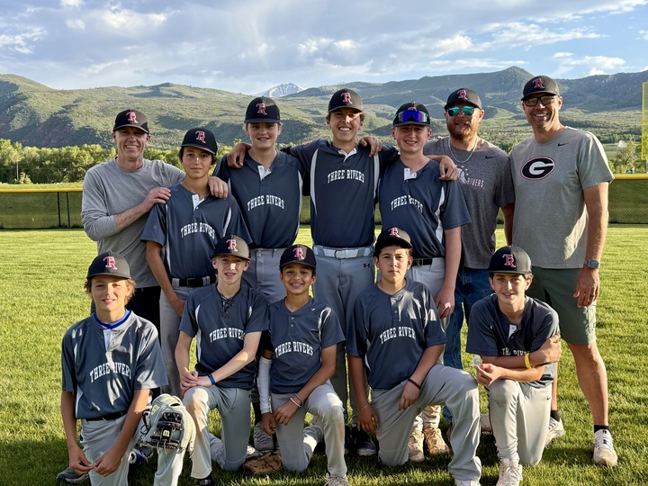

Call to Action
Your sponsorship or donation helps ensure that every child in our community has the chance to play ball.
Ways to Give:
- Venmo: https://account.venmo.com/u/ThreeRiversLittleLeagueCO 
- By check: Three Rivers Little League, PO Box 2184, Glenwood Springs, CO 81602

