Pre Game Warmup - Should take no more than 10 minutes

Blood flow series - 90 feet:
1. Forward jog down
2. Light skip back
3. Back Pedal down
4. Jog half and sprint half

Walking Series – 10 to 20 yards:
1. Walking Knee-Hug
2. Shin Grab
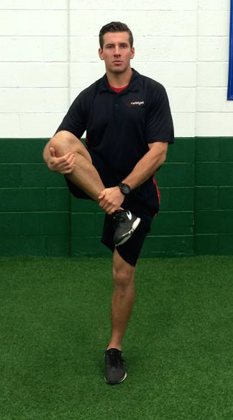
3. Quad Walks
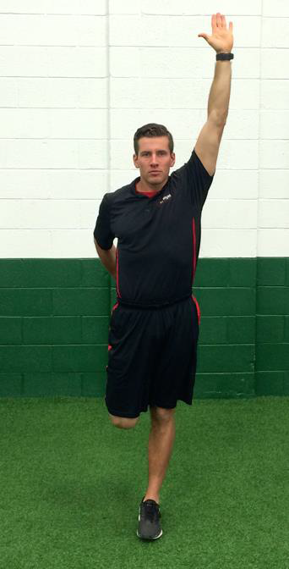

4. Spider Walks - (Heel-to-Toe) walk backwards reaching with opposite hand to pull toes
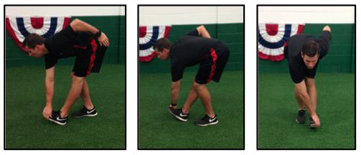
6. Inch Worms
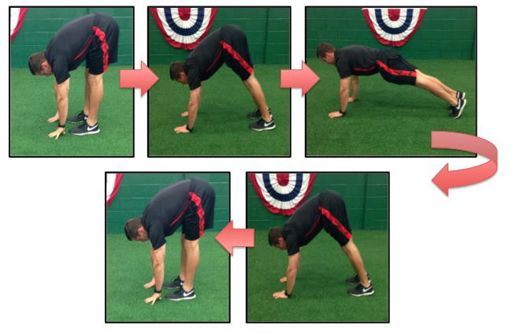
7. Walking 1-leg Toe Touch
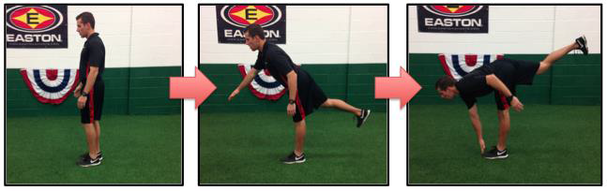

Dynamic Series – 10 to 20 yards:
1. Shuffles (down and back)
2. Cross Step - step across - front foot - back foot (down and back)
3. High-Knees (down and back)
4. Heel-Kicks/Modified Butt-Kickers
5. Power Skip

Foot Fire Series:
1. Ankle Hops
2. 2-foot Lateral Hops
3. 2-foot forward and back hops
4. Hop Scotch - feet out and back in like hop scotch 2-1-2-1 board
5. Scissors - feet go front to back in scissors motion

Shoulder Series – 10 each
1. Torso Rotations
2. Arm Circles
3. Over & Under
4. Scarecrow

